Minimize bruises and wounds this harvest season
By Mike Thornton and Nora Olsen, University of Idaho.

Harvesting a quality crop is an important topic on everybody’s mind for the upcoming season. Blackspot bruise and shatter bruise, or open wounds such as of nicks, cuts, abrasions, are quality issues to focus on and minimize at harvest. The level of shatter bruise can have a huge impact on the potential for disease development and higher weight loss in storage. The pathogens that cause Fusarium dry rot and Pythium leak need a wound to infect the tuber, whereas pathogens that cause pink rot, late blight, early blight and others may not need a wound, but infection is dramatically increased with wounding. Regardless of the type of wound, economic losses can occur due to disease invasion and shrinkage. Here are a few suggestions for a bruise reduction program this harvest:
1) Soil condition - Anything that makes soil separation from tubers at harvest more difficult has the potential to increase bruising. Clods are hard to deal with at harvest time because just about every device used to remove them (shakers, roller tables, etc.) has the potential to injure tubers. Soil moisture conditions at harvest are also important, as very wet or dry conditions make soil separation a challenge.
2) Tuber condition - Tuber temperature, hydration level (crispness) and maturity interact to influence bruise susceptibility. In general, the lower the pulp temperature, the more susceptible tubers are to both shatter and black spot bruising. Pulp temperatures below 45ºF make it very difficult to handle potatoes without causing significant shatter bruise damage. The more hydrated or crisp the potatoes are, the more susceptible they are to shatter bruise. In contrast, dehydrated potatoes are susceptible to black spot bruise. Likewise, as plants mature, the tubers become more susceptible to black spot bruise. Tubers that sit in dry soil under dead or dying vines can become very susceptible to black spot, so it is best to vine kill and harvest before vines reach that stage. Knowledge of the relative bruise susceptibility of the potato varieties you are growing allows you to use tuber hydration level to your advantage. For example, Bannock Russet is known to be relatively susceptible to shatter bruise, but resistant to black spot. Therefore, it is recommended that Bannock fields be harvested under slightly drier conditions to reduce shatter bruise. See the table at the end of this article for information on the bruise susceptibility of some of the most commonly grown potato varieties (Information in that table was provided by Dr. Jeff Stark).
3) Harvester operation - The more susceptible the tubers are to damage, the more important it is to operate the harvester under optimum conditions. Achieving optimum harvester operation requires reducing drops, cushioning impact areas, and setting chain speeds in relation to ground speed so that harvester chains are filled to capacity. If the volume of material (tubers and soil) passing over each chain can be matched to the capacity of that chain, then damage due to excess tuber movement, rollback, and drops can all be reduced.
4) Bruise after the harvester - Getting potatoes into the truck with minimum damage is only the beginning of a bruise reduction program. It has been reported that about 30% of all bruise damage found on tubers in storage occurs after the harvester. Bruise reduction during the trucking and piling operations involves minimizing drops, matching conveyor speed to tuber volume, and piling in a progressive, stepwise fashion to minimize tubers rolling down the face of the pile. Systematically observe each area of the handling equipment to minimize drops.
5) Bruise on the way to market - Surveys show that potatoes can experience extensive damage during the packing, shipping and receiving operations. Fortunately, the level of damage caused during these handling steps can be significantly reduced by making minor modifications such as lowering drops, filling equipment to capacity and cushioning impact points.
6) The human factor - Most potato handling operations are performed by equipment, but there is almost always a human factor involved in managing that equipment in a way that minimizes bruising. Taking time to educate employees about bruise prevention should be a standard part of your harvest preparation. Remind employees to be constantly watchful of where a drop may be too high and make adjustments on the fly to remedy it.
Monitoring bruise incidence throughout your harvest system is a useful way to determine whether bruise susceptibility is higher for a particular lot or field. Taking tuber samples at different points throughout the harvest and handling process (eg. hand dug, harvester, conveyors, any drop points or turns, etc.) and holding them at warm temperatures will allow you to assess the tubers for blackspot damage. The higher the temperature, the quicker the pigment formation will occur and the sooner the results will be available. There are “hot boxes” commercially available for purchase, or rooms can be constructed for this same purpose. Shatter bruise will be apparent regardless of warming the tubers. The use of an instrumented sphere is another way to determine where unacceptable impacts are occurring in harvest, handling or packaging systems.
Additional information is provided in Bulletin 725 "Preventing potato bruise damage" and CIS 1129 "Thumbnail cracks of potato tubers" available from the University of Idaho Communications Department website: http://www.cals.uidaho.edu/edComm/list.aspx?category1=Crops&category2=Potatoes.
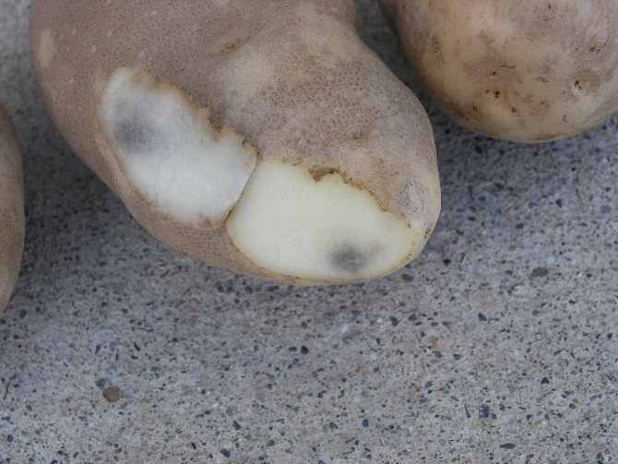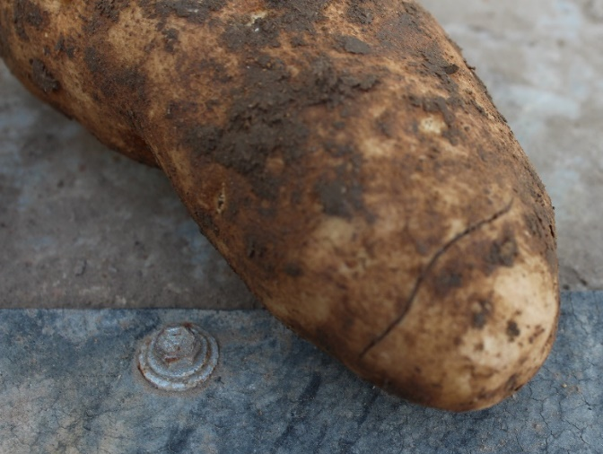
Typical symptoms of blackspot (left) and shatter bruise (right).

Variety | Susceptibility to Shatter Bruise¹ | Susceptibility to Blackspot Bruise¹ | Management Practices to Minimize  Bruise Damage²
Bannock Russet | Very Susceptible | Not Susceptible | - Vine maturity: Little Importance – blackspot bruise is not an important consideration.  - Tuber hydration: Very Important – apply an irrigation to condition soil for harvest only; harvest tubers slightly dehydrated to minimize shatter bruise.  - Wound healing: Critical – provide optimum wound-healing conditions in storage to rapidly heal shatter bruises that may lead to tuber decay.
Ranger Russet | Moderately Susceptible | Very Susceptible | - Vine maturity: Critical – kill vines while most (about 95%) are still green.  - Tuber hydration: Critical – must apply an irrigation 8 days before harvest to hydrate tubers if soil is less than 60% ASM³ to minimize blackspot bruise.  - Wound healing: Important – provide optimum wound-healing conditions in storage to rapidly heal shatter bruises that may lead to tuber decay.
Russet Burbank | Moderately  Susceptible | Susceptible | - Vine maturity: Very Important – kill vines when about 40 percent are matured (dead or dying).  - Tuber hydration: Very important – apply an irrigation 8 days before harvest to hydrate tubers if soil is less than 60% ASM³ to minimize blackspot bruise.  - Wound healing: Important – provide optimum wound-healing conditions in storage to rapidly heal shatter bruises that may lead to tuber decay.
Russet Norkotah | Moderately Susceptible | Moderately Susceptible | - Vine maturity: Somewhat Important – blackspot bruise is not a major concern so time of vine kill has only minor influence on blackspot bruise.  - Tuber hydration: Somewhat Important – apply an irrigation 8 days before harvest if soil is less than 60% ASM³ to help minimize blackspot bruise.  - Wound healing: Important – provide optimum wound-healing conditions in storage to rapidly heal shatter bruises that may lead to tuber decay.
Shepody | Susceptible | Not  Susceptible | - Vine maturity: Little Importance – blackspot bruise is not an important consideration.  - Tuber hydration: Important – apply an irrigation to condition soil for harvest only; harvest tubers slightly dehydrated to minimize shatter bruise.  - Wound healing: Very Important – provide optimum wound-healing conditions in storage to rapidly heal shatter bruises that may lead to tuber decay.
Umatilla Russet | Susceptible | Moderately Susceptible | - Vine maturity: Somewhat Important – blackspot bruise is not a major concern so time of vine kill has only minor influence on blackspot bruise.  - Tuber hydration: Important – apply an irrigation 8 days before harvest if soil is less than 60% ASM³ to help minimize blackspot bruise, but handle carefully to minimize shatter bruise.  - Wound healing: Very Important – provide optimum wound-healing conditions in storage to rapidly heal shatter bruises that may lead to tuber decay.
¹Susceptibility is a subjective ranking using the following order from least to most susceptible:
not susceptible < moderately susceptible < susceptible < very susceptible
²Management practices are rated by relative importance using the follow order from least to most
important: little importance < somewhat important < important < very important < critical
³ASM = available soil moisture

